Project Design Phase-II
Data Flow Diagram & User Stories
Date | 1 NOVEMBER 2025
Team ID | NM2025TMID05413
Project Name | Educational Organisation Using  ServiceNow
Maximum Marks | 5 Marks

Data Flow Diagrams:
A Data Flow Diagram (DFD) is a traditional visual representation of the information flows within a system. A neat and clear DFD can depict the right amount of the system requirement graphically. It shows how data enters and leaves the system, what changes the information, and where data is stored.
It illustrates the flow of data between the Admin, ServiceNow System, and Database Tables such as Salesforce, Admission, and Student Progress. The Admin enters student and admission details, which are automatically processed by ServiceNow through client scripts and business rules. The system generates admission numbers, stores them in the Admission table, and updates progress in the Student Progress table. The DFD highlights how all records are interconnected and securely managed within the ServiceNow Cloud Database, ensuring real-time data access and consistency

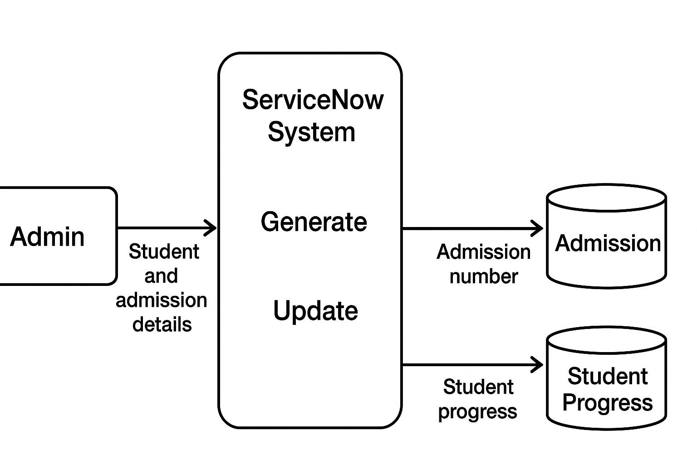

User Stories:
User Type | Functional Requirement (Epic) | User Story Number | User Story / Task | Acceptance Criteria | Priority | Release
Administrator | Admission Management | USN–1 | As an admin, I want to create and manage student admissions using forms in ServiceNow. | The system should allow creating, viewing, and updating student and admission records. | High | Sprint–1
System | Auto Number Generation | USN–2 | As a system, I must generate a unique admission number automatically when a new record is added. | Each student receives a unique admission number without duplication. | High | Sprint–1
Teacher / Staff | Student Progress Tracking | USN–3 | As a staff member, I want to update and monitor student progress records. | The system allows staff to record grades, attendance, and remarks for each student. | Medium | Sprint–2

